**Lab8: *XSS Game* (3%)**

**Name: Khai Phan Student Number: 100901164**

**Results**

**Level 1:**

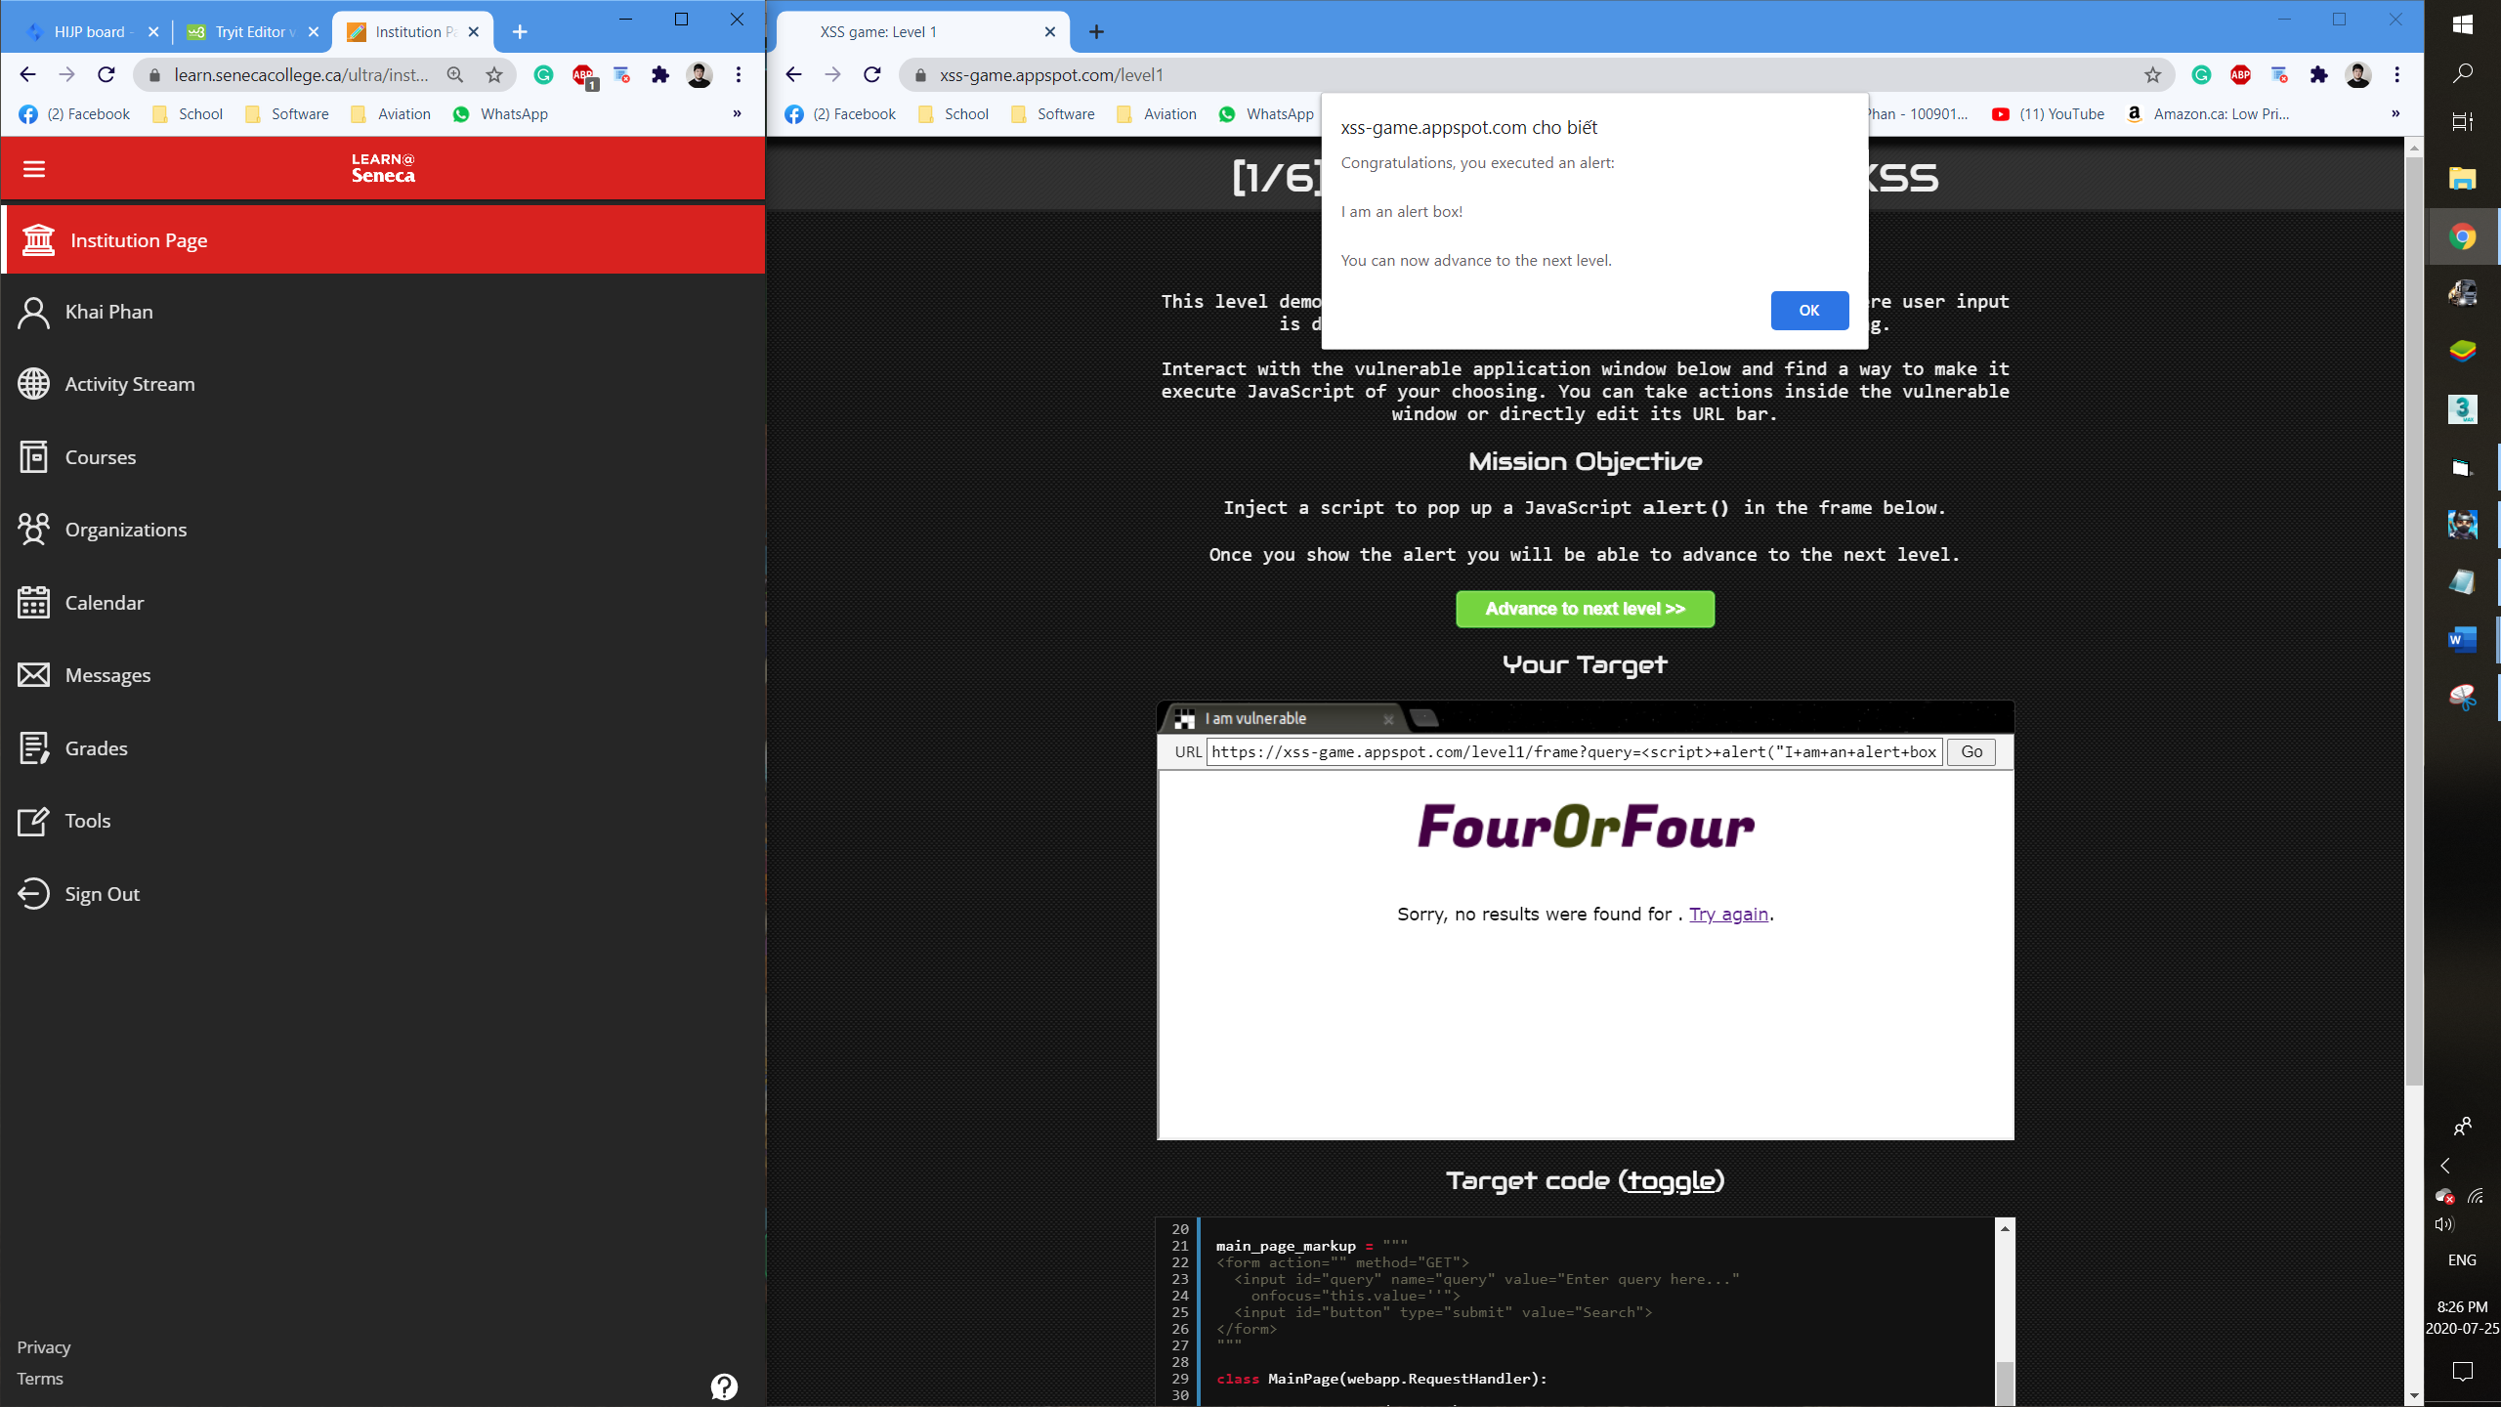

**Level 2:**

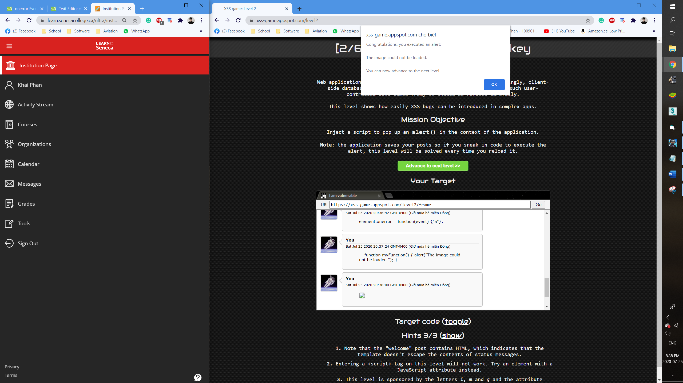

**Level 3:**

